Skill
No. | Logo Software | Keterangan
1 | 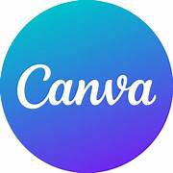 | Canva  95%
2 | 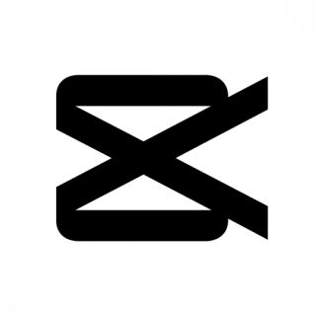 | Capcut  90%
3 | 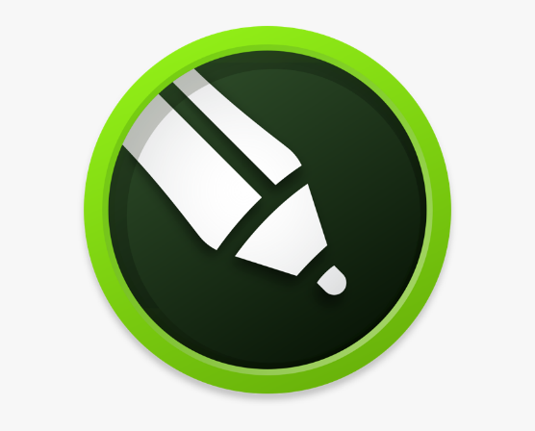 | Corel Draw 98%
4 | 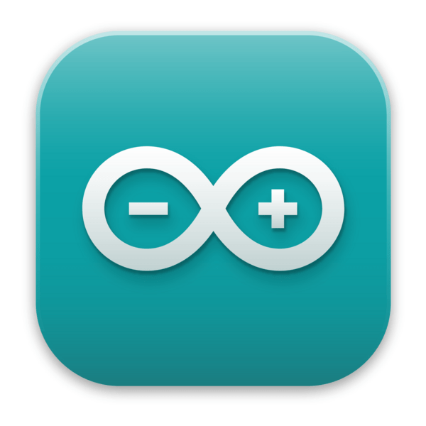 | Arduino IDE 90%
5 |  | VS Code  80%
6 | 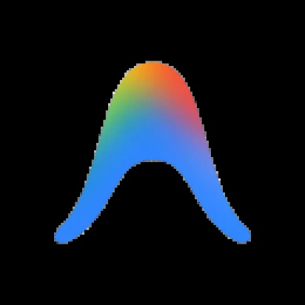 | Antigravity  75%
7 | 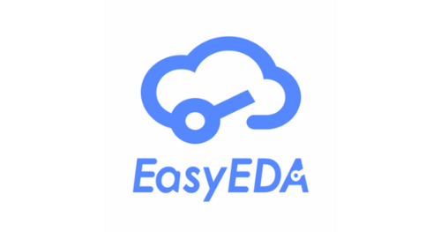 | Easy EDA  92%
8 |  | Proteus  87%
9 | 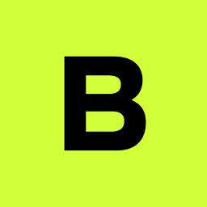 | Blynk  93%
10 |  | Flutter  81%

